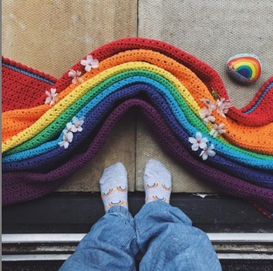

#StayHome Photo Challenge

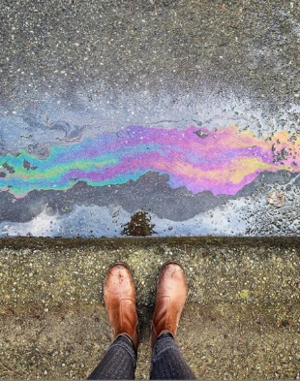
Sara Tasker started this social media challenge as a way for people to share how they are finding joy and creativity in lockdown!

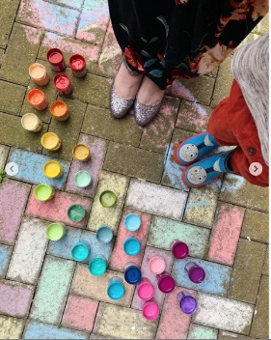
This new social media photo challenge is encouraging people to #StayHome in a beautiful way; helping people stay creative and connected online without having to leave the house.
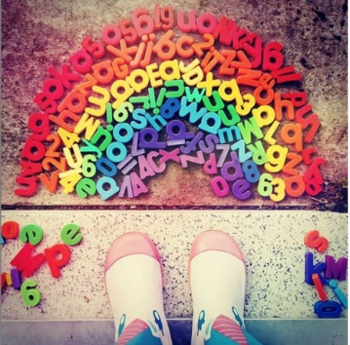

Each week, Sara brings us a new theme. Get creative, snap some photos and upload to social media with the hashtag #StayHome.

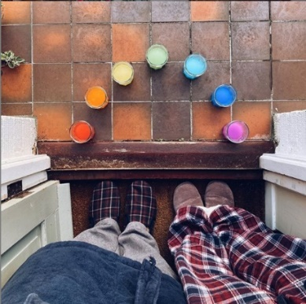
Check out the hashtag and take a look at what other people have uploaded to inspire you!

