**Introduction to Issues and Debates in Psychology**

**What is an Issue?**

An ‘issue’ in psychology refers to a source of conflict that if ignored could undermine the value of our theories and research. Key issues that are a concern for psychologists are:

* Ethical challenges in both human and non-human participant research
* Gender bias
* Cultural bias

**What is a Debate?**

You can think of a ‘debate’ in psychology as being an academic argument that lasts over many years and often appears to have no resolution. However, the important thing about a ‘debate’ on a particular topic is that it enables us to gain a better understanding of any other potential factors involved. Today, many psychologists prefer to take an ‘interactionist’ approach to explain an aspect of behaviour rather than remaining on one side of a debate. Three debates that have a long history within philosophy and psychology are:

* Free will versus determinism
* Reductionism
* Nature versus nurture

Use the booklet of information given to help you complete the following exercises:

**MCPE01701_0000[1]**

Issues exercise 1 : Ethical Issues in Psychology

1. Explain why there has been a need to produce ethical guidelines for our research:
2. What do researchers have to do in order to conduct psychological research using non-human participants?

You want me to find the cheesie reward again? But it’s ruining my figure!

C:\Users\Admin\AppData\Local\Microsoft\Windows\Temporary Internet Files\Content.IE5\8NKS037H\MC900139573[1].wmf

1. Why is the welfare of animals used in research so important?

MCBD20204_0000[1]

1. What ethical considerations do ethics committees scrutinise when professional researchers submit proposals of their work?
2. Explain what is meant by ‘the ends justifying the means’:

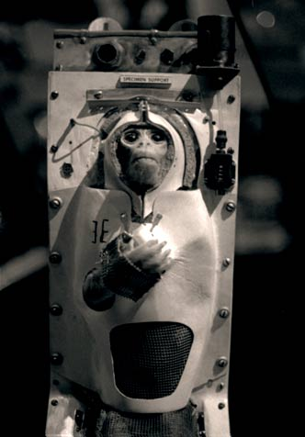

Issues exercise 2 : Cultural Bias

1. C:\Users\Admin\AppData\Local\Microsoft\Windows\Temporary Internet Files\Content.IE5\QH81ZNJ6\MC900438143[1].wmfReferring to both individualistic and collectivist cultures, explain why findings from one culture may not apply to another:

C:\Users\Admin\AppData\Local\Microsoft\Windows\Temporary Internet Files\Content.IE5\QN7YL6ZA\MC900445470[1].wmf

1. How do *ethnocentric* biases occur and what do these lead to?

C:\Users\Admin\AppData\Local\Microsoft\Windows\Temporary Internet Files\Content.IE5\DOJLTV0A\MC900078780[1].wmf

1. Using an example, explain what is meant by the term ‘etic’ and say why this can lead to cultural bias:
2. Explain what is meant by an *emic* approach and say why this method has greater ecological validity:
3. Give an example of research using an *etic* approachthat has led to bias and explain how an *emic* approach has been used to solve this problem:
4. 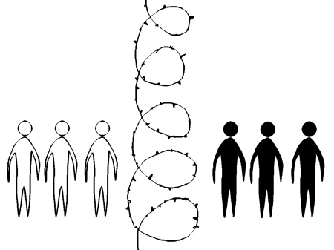What are the consequences of cultural bias?

Issues exercise 3: Gender Bias

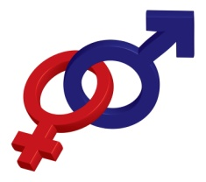

1. Describe an *alpha-bias:*
2. Describe a *beta-bias:*
3. Outline some of the gender biases that can occur in studies due to the way the research has been carried out and comment upon how results could be used to promote inequalities:



1. Explain why research supporting differences between men and women is more likely to be published:
2. Why is it wrong to assume that all research has a gender bias?
3. Subtle differences found in research between men and women might be exaggerated to support gender differences. Explain how this could lead to the maintenance of the gender supremacy of men in our society:



Debates exercise 1 : Determinism and Freewill

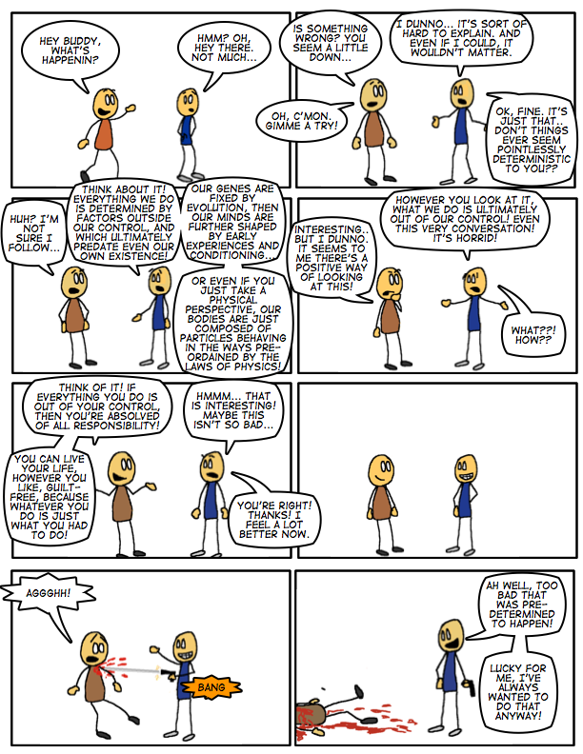

1. Outline a deterministic viewpoint:
2. What do psychologists who take the free will approach suggest?



1. Outline how a deterministic explanation for behaviour, e.g., aggression, reduces individual responsibility:

[](http://www.google.co.uk/imgres?imgurl=http://www.ac-nancy-metz.fr/enseign/anglais/Henry/domesticviolence.jpg&imgrefurl=http://www.ac-nancy-metz.fr/enseign/anglais/Henry/civiviolence.htm&usg=__h9TB8k8RL5IXO-tOFaCHLT53jao=&h=424&w=342&sz=30&hl=en&start=5&itbs=1&tbnid=6uztm8IPmjpeQM:&tbnh=126&tbnw=102&prev=/images?q=domestic+violence&hl=en&gbv=2&tbs=isch:1)

1. Why does a determinist approach have important implications for psychology as a science?

.

1. 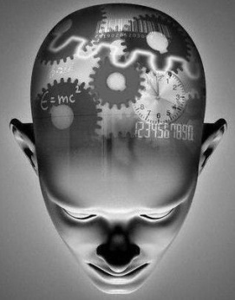Why is human behaviour such a problem for psychologists taking a determinist view?
2. Explain what is meant by ‘soft determinism’:



Debates exercise 2 : Reductionism

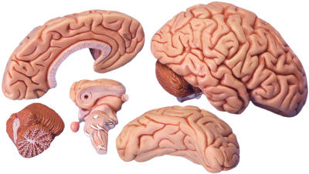

1. According to a reductionist approach, what is the best way to explain our behaviour and why do supporters argue that it is scientific?
2. Describe how reductionism operates at different levels:
3. Outline the argument against the validity of a reductionist view:
4. 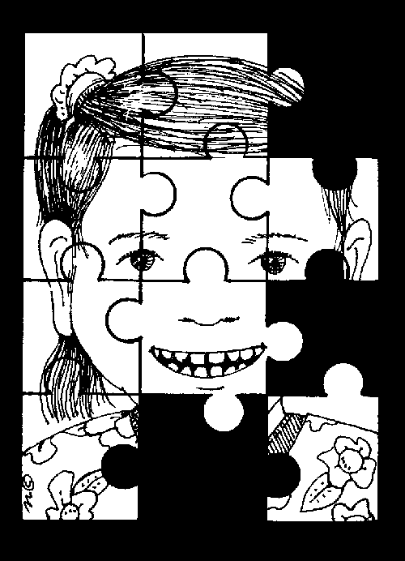Why can reductionism sometimes lead to incomplete explanations for behaviour?



1. Describe how interactionism differs from reductionism and say how this way of looking at our behaviour might help us better explain mental disorders such as depression:

Debates exercise 3 - The Nature/Nurture Debate

1. Outline what is meant by the ‘nature’ part of the debate:



1. Giving an example, what do ‘nativists’ strongly support?
2. How do biological approaches explain behaviour?

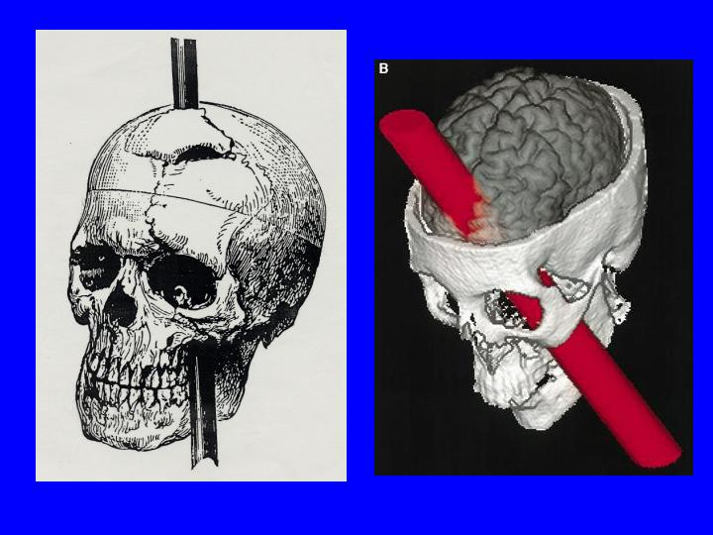

1. Outline what is meant by the ‘nurture’ side of the debate:





1. Using an example, explain the empiricist view of the nurture argument:
2. Nativist and empiricist approaches represent extreme sides of the argument, and today, psychologists tend to take the interactionist view that behaviour is influenced by both nature and nurture. Explain why it is limiting to describe behaviour solely in terms of nature or nurture and provide an example of your own to illustrate this problem: