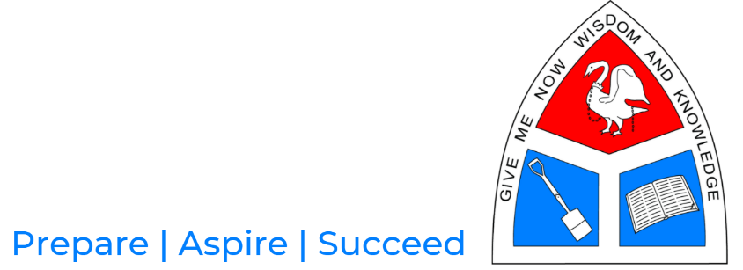

GUIDANCE NOTES

Last year we had to cancel work Experience because of Lockdown. Who knows what the future holds in this respect, but we are going to be positive and optimistic that Work Experience will go ahead this year. The dates booked are the last two weeks of the Summer term.

As always it is the responsibility of each student to secure and manage their own placement. The Application form can be found on the Careers section of the School Website.

As there is no longer any Government funding for such projects, we need to implement this programme at a minimum cost. In order to achieve this, it will be the responsibility of each student to find a placement and complete, with the prospective employer, the necessary application forms.

To guarantee a place on the programme each application must fulfil the following criteria
• the placement should be with a recognised, high profile company, who have a history of successfully accommodating Work Experience students.
• the application form is completed fully by all parties, with particular attention to the Employer’s Liability Insurance number, and submitted by the first week of the Summer term.

Please note, the DBS can be waived if the student is working with their parent or close family relative. This can, after negotiation and approval by myself, be applied to the Employer Liability Insurance.

If I am in any way unsure about the suitability of a proposed placement or if any part has not been completed, the placement will not be authorised and an alternative will have to be found. Students can work in multiple placements during the two weeks providing that an application form for each placement is submitted.

Students who decline to be part of the programme will follow their normal timetable during the Work Experience period and will be expected to complete a placement during the Summer Holidays.

All the necessary forms and guidance can be downloaded from the school website; these can be found under ‘students’ and then ‘careers’. These will need to be completed and submitted to the school by first week after Easter Holidays.

Please note that we are in competition to secure placements with other schools in Bucks so it is important to act quickly.

I would like to draw your attention to the following sections of the Application Form that have had to be included due to the current Pandemic:
• Bullet Point 3 at the end of Section 2
• The final sentence of the Statement at the beginning of Section 3
• The final sentence at the beginning of Section 4

Mr Matcham

