A Level Physics Transition Baseline Assessment

40 Marks – 40 Minutes
A single piece of graph paper is required for the completion of the assessment.
You may use a calculator.

Question Number | Topic | Score
1 | Symbols and Prefixes | /3
2 | Standard Form | /4
3 | Re-arranging Equations | /3
4 | Atomic Structure | /3
5 | Recording Data | /3
6 | Graphing | /4
7 | Forces and Motion | /10
8 | Electrical Circuits | /5
9 | Waves | /5
 |  | Total /40

Q1 Complete the following table:
Unit prefix | Meaning
k (kilo) | x 1000
 | X 0.000001

M (mega)

N (nano)

[3]

Q2

Write the following numbers into standard form.

0.012

120000

0.00000012

[3]

Complete the following calculations and right your answers to an appropriate number of significant figures.

2.1 X 0.15

0.345 ÷ 0.114

[4]

Q3 Re-arrange the following equations to make R the subject of the equation.

$Q=WERTY$

$Q^{2}=WR^{2}$

$Q=W-RT^{2}$

[3]

Q4 Name the 3 particles (from GCSE) that make up an atom.

……………………………………………………………………………………………………………………………………………… [1]

Which one of the above particles is not found in the nucleus of an atom?

……………………………………………………………………………………………………………………………………………… [1]

Which of the above particles will be found in varying quantities in the nuclei of isotopes of the same element?

……………………………………………………………………………………………………………………………………………… [1]

Q5

Complete the following table
Voltage (__) | __________ (A)
 | Repeat 1 | Repeat 2 | Average
2 | 0.23 | 0.26 | 0.25
4 | 0.46 | 0.53
6 | 0.69 | 0.78 | 0.74
8 | 0.92 | 1.04 | 0.98
10 | 1.15 | 1.30 | 1.23

[3]

Q6

a) Use your piece of graph paper to plot a graph of Current (x-axis) against Voltage (y-axis) drawing a line of best fit through your data points.

[4]

b) Find the gradient of your line of best fit

[3]

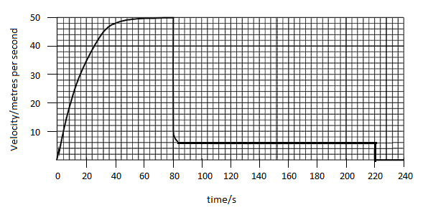
Q7 The graph below shows the journey of a skydiver after they have left the plane.
a) Explain the shape of the graph commenting on how and why the forces have changed.
______________________________________________________________________________________________________________________________________________________________________________________________________________________________________________________________________________________________________________________________________________________________________________________________________________________________________________________________________________________________________________________________________________________________________________________________________________________________________________________________________________________________________________________________________________________________________________________________________________________________________________________________________________________________________________________________________________________________________________________________________________________________________________________________________________________________________________________________________________________________________________________________________________________________________________________________________________________________________________________________________________________________________________________________________
[6]

b) Calculate the distance travelled whilst at the second terminal velocity.

[2]
c) Calculate the average acceleration in the first 20 seconds.

[2]

Q8

Draw a circuit diagram to show how the resistance of a filament bulb could be measured using an ammeter and a voltmeter.

[2]

Look at the circuit diagram below. All of the resistors are identical.

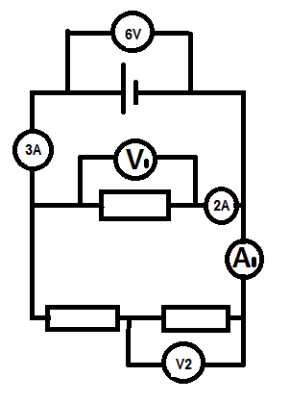

Write the missing values of current and potential difference:

V1 =

V2 =

A1 =

[3]

Q9 The diagram below shows a diagram of 3 complete longitudinal wave oscillations on a slinky:

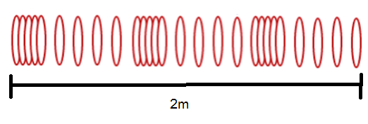

State the wavelength of the wave shown

…………………………………………………………………………………………………………………………………………………… [1]

Label a complete wavelength on the diagram above with the correct symbol used for wavelength in GCSE and A Level Physics

[1]

If the above wave had a frequency of 5Hz how long would it take an individual hoop to complete 1 full oscillation?

[1]

d) Calculate the speed of the wave

$$wavespeed=frequency ×wavelength$$

Wave speed = ____________ Unit _______[2]

