Free home workouts

Who | Link | Description
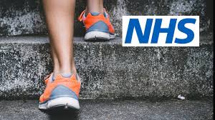 | https://www.nhs.uk/conditions/nhs-fitness-studio/?tabname=strength-and-resistance | 10-minute workouts  Fitness plans  Physical exercise guidelines  Aerobic exercise  Pilates and Yoga  Strength based exercise
 | https://www.youtube.com/channel/UCBINFWq52ShSgUFEoynfSwg | Access to over 500 workouts from celebrity trainers and fitness experts across strength, cardio, dance and yoga
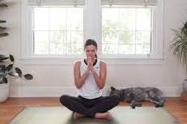 | https://www.youtube.com/user/yogawithadriene | Yoga with Adriene has a wide range of practices that are great for the body but more importantly awesome for your mental health too
 | https://www.fitnessblender.com/videos | Free workout videos from low impact, to HIIT and strength training
 | https://watch.lesmillsondemand.com/at-home-workouts | This temporary site allows free access to 100+ workouts during the COVID-19 disruptions

