Answers at the end
Description 4
‘This is a low mood that lasts for a long time, and affects your everyday life. In its mildest form, it can mean just being in low spirits. It doesn’t stop you leading your normal life but makes everything harder to do and seem less worthwhile. At its most severe, it can be life-threatening because it can make you feel suicidal or simply give up the will to live.’ – Mind

Description 5
‘This is what we feel when we are worried, tense or afraid – particularly about things that are about to happen, or which we think could happen in the future. This is a natural human response when we perceive that we are under threat. It can be experienced through our thoughts, feelings and physical sensations.’ – Mind
Description 6
‘This is a mental health condition that affects a person’s mood, energy and ability to function. It is characterised by extreme mood states, or episodes, described as:
Manic or hypo-manic episodes (feeling high)
Depressive episodes (feeling low)
Potentially psychotic symptoms – where an individual experiences delusions or hallucinations’ – MQ Mental Health

Description 7
‘This is a severe mental illness, which disrupts how someone thinks, their understanding and perception of the world around them, including what they see or hear. Quite often the condition will cause psychotic symptoms, which means the distinction between thoughts and reality become blurred - a person may experience delusions or hallucinations. This can make the condition alarming and confusing for both the person affected, and their family and loved ones.’ – MQ Mental Health

Description 3
‘This is a lifelong, developmental disability that affects how a person communicates with and relates to other people, and how they experience the world around them.’ – NAS. This is not a mental illness, but could impact mental wellbeing.
Description 8
‘This is when a person’s eating habits and relationship with food becomes difficult. This can disrupt how a person eats food and absorbs nutrients, which affects physical health, but can also be detrimental both emotionally and socially.’ – MQ Mental Health
Description 2
‘This is when you perceive or interpret reality in a very different way from people around you. You might be said to 'lose touch'. The most common symptoms are hallucinations & delusions. This affects people in different ways. You might experience it once, have short episodes throughout your life, or live with it most of the time.’ – Mind

Description 1
‘This is a form of depression that people experience at a particular time of year or during a particular season. It is a recognised mental health disorder. if you experience this, the change in seasons will have a much greater effect on your mood and energy levels, and lead to symptoms of depression that may have a significant impact on your day-to-day life.’ – Mind

Eating Disorders
Seasonal Affective Disorder
Anxiety
Depression
Bipolar
Schizophrenia
Autism
Psychosis
Match Up Activity

Match up the illnesses/disabilities below with the correct definitions:

Mental Health Continuum
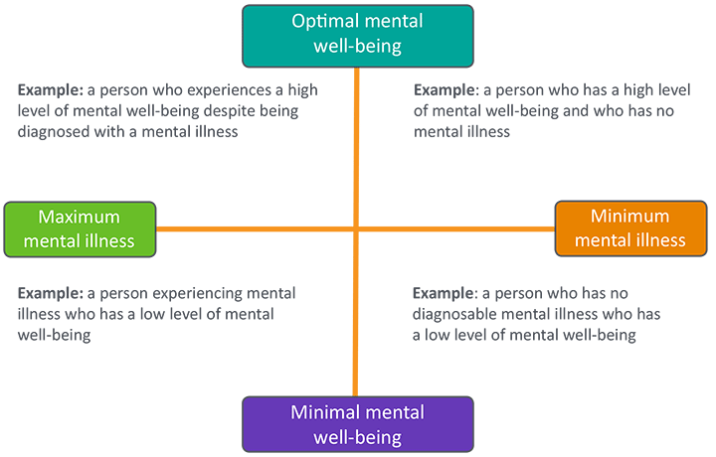
Stigma
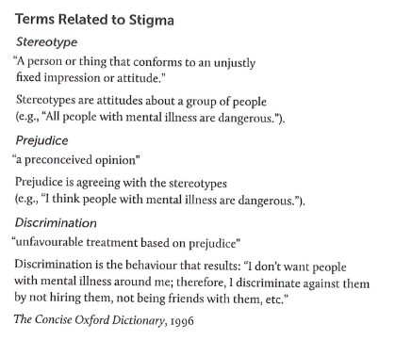
If something has a stigma attached to it, people think it is something to be ashamed of.
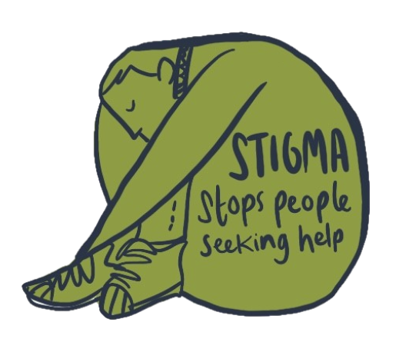

Personal Attitude Survey
Answers at the end
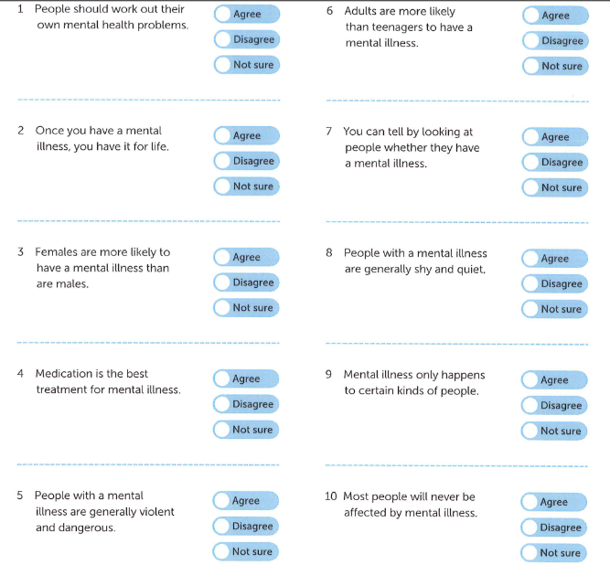

Answers

Mental illness match-up:
Anxiety – 5
Depression – 4
Bipolar – 6
Schizophrenia – 7
Eating Disorders – 8
Autism – 3
Psychosis – 2
Seasonal Affective Disorder – 1

Personal Attitude Survey:
Best answers

