Fun Science Experiments to Practice at Home

Mixing Oil and Water
Some things just don't get along well with each other. Take oil and water as an example, you can mix them together and shake as hard as you like but they'll never become friends....or will they? Take this fun experiment a step further and find out how bringing oil and water together can help you do your dishes.
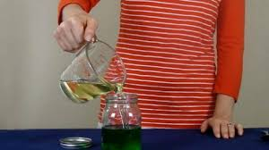
What you'll need:
- Small soft drink bottle
- Water
- Food colouring
- 2 tablespoons of cooking oil
- Dish washing liquid or detergent
Instructions:
- Add a few drops of food colouring to the water.
- Pour about 2 tablespoons of the coloured water along with the 2 tablespoons of cooking oil into the small soft drink bottle.
- Screw the lid on tight and shake the bottle as hard as you can.
- Put the bottle back down and have a look, it may have seemed as though the liquids were mixing together but the oil will float back to the top.
What's happening?
While water often mixes with other liquids to form solutions, oil and water does not. Water molecules are strongly attracted to each other, this is the same for oil, because they are more attracted to their own molecules they just don't mix together. They separate and the oil floats above the water because it has a lower density.

If you really think oil and water belong together then try adding some dish washing liquid or detergent. Detergent is attracted to both water and oil helping them all join together and form something called an emulsion. This is extra handy when washing those greasy dishes, the detergent takes the oil and grime off the plates and into the water, yay!

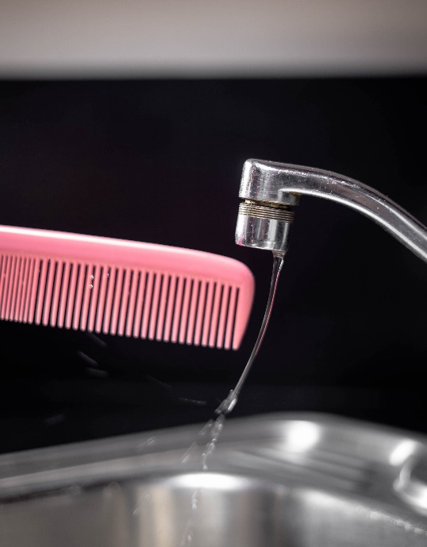
Bend water with static electricity

You will need:
- A dry plastic comb
- An indoor tap
- A head full of clean dry hair.

What to do:
- Turn on the tap and slowly turn down the water until you have a VERY thin stream of water flowing.
- Take the plastic comb and brush it through your hair ten times.
- Now slowly bring the comb close the flowing water, (without actually touching the water) If all goes well, the stream of water should bend towards the comb!

How does it work?
When you brushed that comb through your hair, tiny parts of the atoms in your hair, called ELECTRONS, collected on the comb. These electrons have a NEGATIVE charge. Remember that, its important. Now that the comb has a negative charge, it is attracted to things that have a POSITIVE charge. It is similar to the way some magnets are attracted to certain metals.

When you bring the negatively charged comb near the tap it is attracted to the POSITIVE force of the water. The attraction is strong enough to actually pull the water towards the comb as it is flowing! If you want to try another experiment with your comb, tear up pieces of tissue until they are as a small as you can get them…I mean really small! Then charge your comb again by brushing it through your hair and bring it close to the tiny pieces of tissue. If the pieces are small enough, they will jump off the table to the comb the same way that the water was pulled to the comb. It is all thanks to the wonders of static electricity.

Clean Pennies with Vinegar
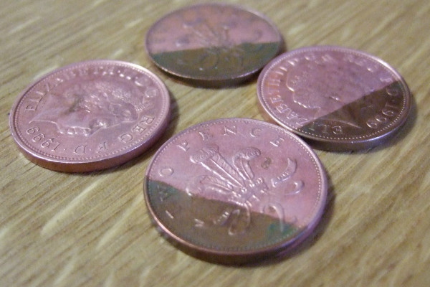
You will need:
- A few old (not shiny) pennies
- 1/4 cup white vinegar
- 1 teaspoon salt
- Non-metal bowl
- Paper towels

What to do:
- Pour the vinegar into the bowl and add the salt – stir it up.
- Put about 5 pennies into the bowl and count to 10 slowly.
- Take out the pennies and rinse them out in some water. Admire their shininess!

How does it work?
There is some pretty fancy chemistry going on in that little bowl of yours. It turns out that vinegar is an acid, and the acid in the vinegar reacts with the salt to remove what chemists call copper oxide which was making your pennies dull. You’re not done yet, though, let’s try another experiment:

Add more pennies to the bowl for 10 seconds, but this time, don’t rinse them off. Place them on a paper towel to dry off. In time the pennies will turn greenish-blue as a chemical called malachite forms on your pennies.

https://sciencebob.com/
http://www.sciencefun.org/kidszone/experiments/

