Van Gogh: Challenging the Myth of the 'Tortured Genius'
Watch this video and then answer the questions below: *Trigger warning – there is discussion of suicide within the video.
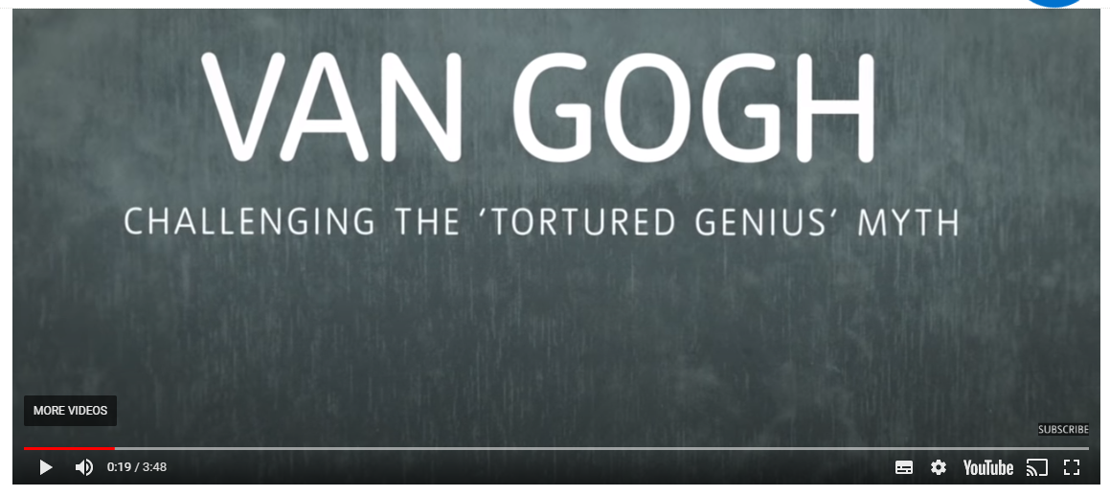

- What is your understanding of the term ‘tortured genius?’ What type of person would you describe to fit this term? ………………………………………………………………………………………………………………………………………………………………………………………………………………………………………………………………………………………………………………………………………………………………………………………………
- Why is it problematic to say that Van Gogh’s artistic talent was because of his poor mental health?
………………………………………………………………………………………………………………………………………………………………………………………………………………………………………………………………………………………………..
- What happened to Van Gogh before he cut off his ear?
………………………………………………………………………………………………………………………………………………………………………………………………………………………………………………………………………………………………
- What treatment did Van Gogh receive in the asylum?
………………………………………………………………………………………………………………………………………………………………………………………………………………………………………………………………………………………………..
- How did art help Van Gogh?
……………………………………………………………………………………………………………………………………………………………………………………………………………………………………………………………………………………………….
- Why do you think suicide was considered a crime?
……………………………………………………………………………………………………………………………………………………………………………………………………………………………………………………………………………………………….

