Virtual Culture in Quarantine
Though the summer season is all but cancelled, theatre lovers need not despair – there is a plethora of world-class shows streaming online for your entertainment and virtual viewing pleasure.
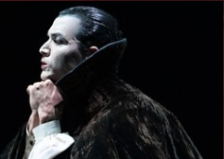
https://www.countryandtownhouse.co.uk/culture/virtual-theatre/ - Country and Town House
https://www.bbc.co.uk/arts - BBC Arts

Do you like creating your own original music?
https://www.bbc.co.uk/programmes/articles/4mY3MbSJ5G2LvSbzZPbc85G/bbc-young-composer-2020 -
BBC Young Composer 2020
https://www.bbc.co.uk/programmes/b00bb3wt - BBC Young Musician 2020

10 European Museums you can visit from your home

From the Rijksmuseum to Tate Britain, sit back, relax and explore.

https://www.countryandtownhouse.co.uk/culture/museums-you-can-visit-from-home/

