Gratitude Meditations
Many social psychologists believe that gratitude isn’t our default setting. For survival purposes, humans were designed with instincts sensitive to the merest whiff of anything amiss. Our ancestors were hardwired — not so much to appreciate a magnificent sunset, but to scan for a shadowy presence that could indicate danger. Psychologists think this tendency to live more fully in our negative emotions rather than in our positive ones is an inherited evolutionary predisposition.

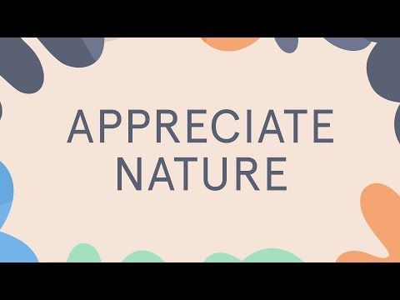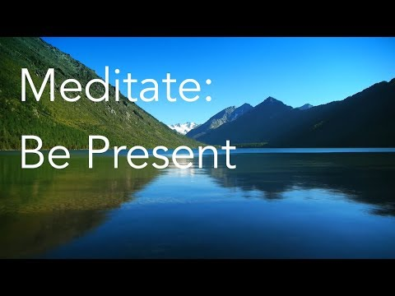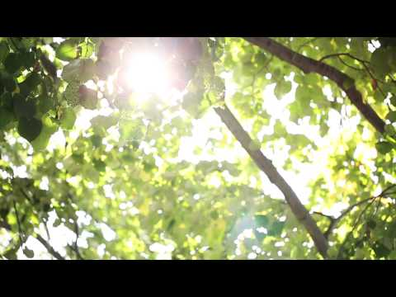

Meditation isn’t always easy especially when the mind is aggressively wandering and distracting your attention, but if you practice this kind of mediation consistently be prepared to experience incredible upgrades in gratitude and joy.

