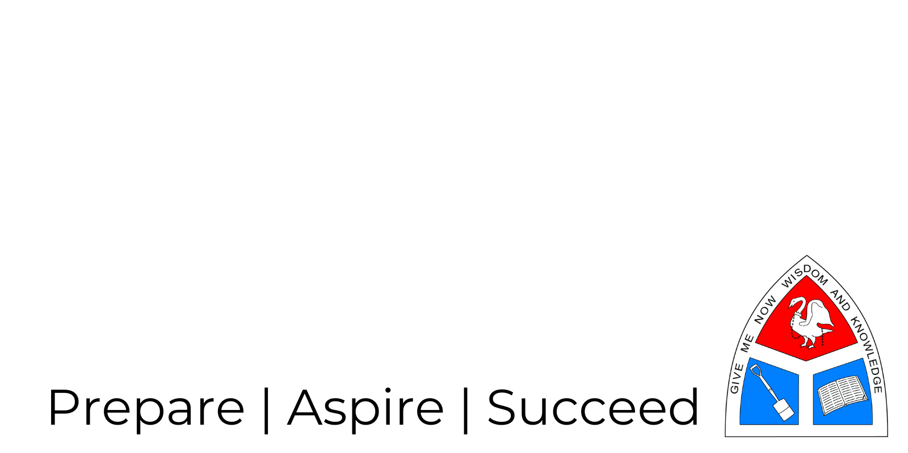

Transition Pack for Applied Human Biology

Get ready for BTEC! A guide to help you get ready for BTEC Applied Human Biology, including everything from topic guides to days out and online learning courses.

Mrs Beatty & Mrs Woodburn
The Cottesloe School

Book Recommendations:

Studying at Post 16 is not just about what goes on in lessons! The books below are all popular science books and great for extending your understanding of Biology.
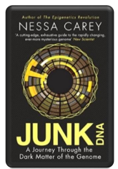
Junk DNA

Our DNA is so much more complex than you probably realize, this book will really deepen your understanding of all the work you will do on genetics. Available at amazon.co.uk

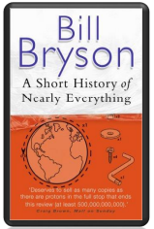

A Short History of Nearly Everything

A whistle-stop tour through many aspects of history from the Big Bang to now. This is a really accessible read that will re-familiarise you with common concepts and introduce you to some of the more colourful characters from the history of science! Available at amazon.co.uk

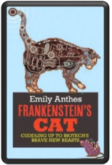

An easy read..

Frankenstein’s Cat

Discover how glow in the dark fish are made and more great biotechnology breakthroughs. Available at amazon.co.uk

Movie Recommendations:

You may have seen these films before but have you ever considered them from a scientific point of view? These films use topics from Applied Human Biology, some are more fiction than fact, what do you think?
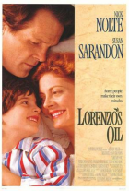

Lorenzo’s Oil (1992)

Based on a true story. A young child suffers from an autoimmune disease. The parents research and challenge doctors to develop a new cure for his disease.

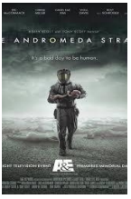

Andromeda Strain (1971)

Science fiction by the great thriller writer Michael Cricthon (most famous for writing Jurassic Park). Humans begin dying when an alien microbe arrives on Earth.

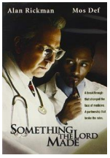

Something the Lord Made (2004)

Professor Snape (the late great Alan Rickman) in a very different role. The film tells the story of the scientists at the cutting edge of early heart surgery as well as issues surrounding racism at the time.

Online presentations:

There are lots of good (and some not so good) talks and presentations online with links to Applied Human Biology. You might consider looking at some of these?

A New Superweapon in the Fight Against Cancer

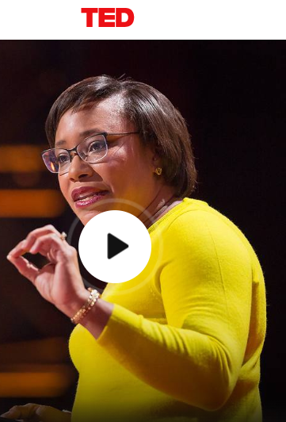
https://www.ted.com/talks/paula_hammond_a_new_superweapon_in_the_fight_against_cancer?language=en

Cancer is a very clever, adaptable disease. To defeat it, says medical researcher and educator Paula Hammond, we need a new and powerful mode of attack.

What Doctors Don’t Know About the Drugs They Prescribe

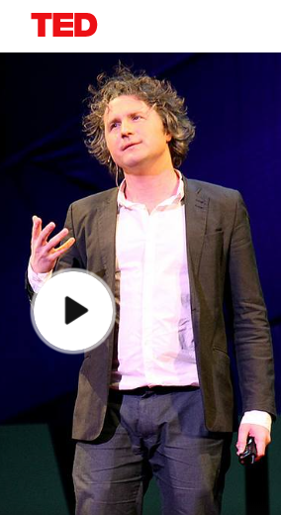
https://www.ted.com/talks/ben_goldacre_what_doctors_don_t_know_about_the_drugs_they_prescribe?language=en

When a new drug gets tested, the results of the trials should be published for the rest of the medical world — except much of the time, negative or inconclusive findings go unreported, leaving doctors and researchers in the dark.

Transition Work - Task 1 - DNA and the Genetic Code

In living organisms nucleic acids (DNA and RNA) have important roles and functions related to their properties. The sequence of bases in the DNA molecule determines the structure of proteins, including enzymes. The double helix and its four bases store the information that is passed from generation to generation. The sequence of the base pairs adenine, thymine, cytosine and guanine tell ribosomes in the cytoplasm how to construct amino acids into polypeptides and produce every characteristic we see. DNA can mutate leading to diseases including cancer and sometimes anomalies in the genetic code are passed from parents to babies in diseases such as cystic fibrosis, or can be developed in unborn foetuses such as Downs Syndrome.

Read the information on these websites:

http://www.bbc.co.uk/education/guides/z36mmp3/revision
http://www.s-cool.co.uk/a-level/biology/dna-and-genetic-code

And take a look at these videos:
http://ed.ted.com/lessons/the-twisting-tale-of-dna-judith-hauck
http://ed.ted.com/lessons/where-do-genes-come-from-carl-zimmer

Task:

Produce a wall display to put up in your classroom in September. You might make a poster or do this using PowerPoint or similar. Your display should use images, keywords and simple explanations to: • Define gene, chromosome, DNA and base pair • Describe the structure and function of DNA and RNA • Explain how DNA is copied in the body • Outline some of the problems that occur with DNA replication and what the consequences of this might be.

Transition Work - Task 2 - Exchange and Transport

Organisms need to exchange substances selectively with their environment and this takes place at exchange surfaces. Factors such as size or metabolic rate affect the requirements of organisms and this gives rise to adaptations such as specialised exchange surfaces and mass transport systems. Substances are exchanged by passive or active transport across exchange surfaces. The structure of the plasma membrane enables control of the passage of substances into and out of cells.

Read the information on these websites: http://www.s-cool.co.uk/a-level/biology/gas-exchange
http://www.s-cool.co.uk/a-level/biology/nutrition-and-digestion/revise-it/human-digestive-system

And take a look at these videos: http://ed.ted.com/lessons/insights-into-cell-membranes-via-dish-detergent-ethan-perlstein
http://ed.ted.com/lessons/what-do-the-lungs-do-emma-bryce

Task:

Compare exchange surfaces in exchange surfaces in the lungs and the intestines.

You could use a Venn diagram to do this.

You must include the following detail:
• Describe diffusion, osmosis and active transport
• Explain why oxygen and glucose need to be absorbed and waste products removed

Transition Work - Task 3 - Cells

The cell is a unifying concept in biology, you will come across it many times during your two years of A level study. Prokaryotic and eukaryotic cells can be distinguished on the basis of their structure and ultrastructure. In complex multicellular organisms, cells are organised into tissues, tissues into organs and organs into systems. During the cell cycle genetic information is copied and passed to daughter cells. Daughter cells formed during mitosis have identical copies of genes while cells formed during meiosis are not genetically identical.

Read the information on these websites: http://www.s-cool.co.uk/a-level/biology/cells-and-organelles
http://www.bbc.co.uk/education/guides/zvjycdm/revision

And take a look at these videos: https://www.youtube.com/watch?v=gcTuQpuJyD8
https://www.youtube.com/watch?v=L0k-enzoeOM
https://www.youtube.com/watch?v=qCLmR9-YY7o

Task:

Produce a one page revision guide to share with your class in September summarising one of the following topics:
Cells and Cell Ultrastructure,
Prokaryotes and Eukaryotes, or
Mitosis and Meiosis.

Whichever topic you choose, your revision guide should include:
• Key words and definitions
• Clearly labelled diagrams
• Short explanations of key ideas or processes.

Transition Work - Task 4 - Biological Molecules

Biological molecules are often polymers and are based on a small number of chemical elements. In living organisms carbohydrates, proteins, lipids, inorganic ions and water all have important roles and functions related to their properties. DNA determines the structure of proteins, including enzymes. Enzymes catalyse the reactions that determine structures and functions from cellular to whole-organism level. Enzymes are proteins with a mechanism of action and other properties determined by their tertiary structure. ATP provides the immediate source of energy for biological processes.

Read the information on these websites: http://www.s-cool.co.uk/a-level/biology/biological-molecules-and-enzymes
http://www.bbc.co.uk/education/guides/zb739j6/revision

And take a look at these videos: https://www.youtube.com/watch?v=H8WJ2KENlK0
http://ed.ted.com/lessons/activation-energy-kickstarting-chemical-reactions-vance-kite

Task:

Krabbe disease occurs when a person doesn’t have a certain enzyme in their body. The disease affects the nervous system.

Write a letter to a GP or a sufferer to explain what an enzyme is.

Your letter should:
• Describe the structure of an enzyme
• Explain what enzymes do inside the body

Transition Work - Task 5 - Control Systems

Homeostasis is the maintenance of a constant internal environment. Negative feedback helps maintain an optimal internal
state in the context of a dynamic equilibrium. Positive feedback also occurs. Stimuli, both internal and external, are detected leading to responses. The genome is regulated by a number of factors. Coordination may be chemical or electrical in nature.

Read the information on these websites:
http://www.s-cool.co.uk/a-level/biology/homeostasis
http://www.bbc.co.uk/education/topics/z8kxpv4

And take a look at these videos:
https://www.youtube.com/watch?v=x4PPZCLnVkA
https://www.youtube.com/watch?v=x4PPZCLnVkA

Task:

Produce a set of revision flash cards summarising one of the following topics: Temperature Control,
Water and the Kidneys,
Glucose, or
The Liver.

Whichever topic you choose, your cards should include:
- Key words and definitions
- Clearly labelled diagrams
- Short explanations of key ideas or processes.

Transition Work - Task 6 - Scientific and Investigative Skills

As part of your BTEC you will complete several practical assignments. These will require you to carry out a series of practical activities as well as planning how to do them, analysing the results and evaluating the methods.

This will require you to: use appropriate apparatus to record a range of quantitative measurements (to include mass, time, volume, temperature, length and pH), use appropriate instrumentation to record quantitative measurements, such as a colorimeter or photometer, use laboratory glassware apparatus for a variety of experimental techniques to include serial dilutions, use of light microscope at high power and low power, including use of a graticule, produce scientific drawing from observation with annotations, use qualitative reagents to identify biological molecules, safely and ethically use organisms, use microbiological aseptic techniques, including the use of agar plates and broth.

Task:

Produce a glossary for the following key words:

accuracy, anomaly, calibration, causal link, chance, confounding variable, control experiment, control group, control variable, correlation, dependent variable, errors, evidence, fair test, hypothesis, independent, null hypothesis, precision, probability, protocol, random distribution, random error, raw data, reliability, systematic error, true value, validity, zero error.

Science Websites

These websites all offer an amazing collection of resources that you should use again and again throughout your course.

https://learn.genetics.utah.edu/

Probably the best website on biology…. ‘Learn Genetics’ from Utah University has so much that is pitched at an appropriate level for you and has lots of interactive resources to explore, everything from why some people can taste bitter berries to how we clone mice or make glow in the dark jelly fish.

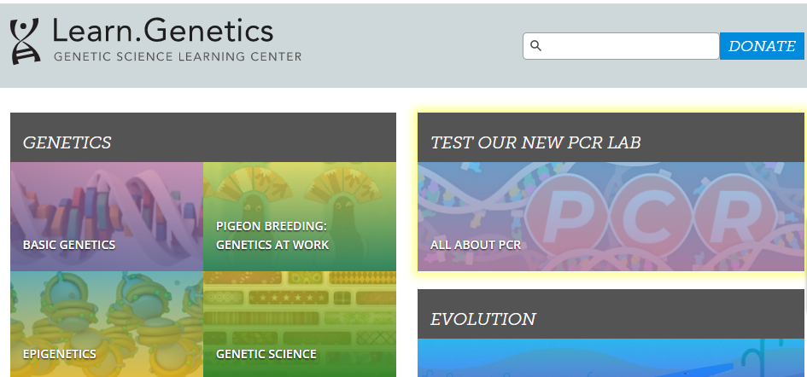

http://www.dnaftb.org/

‘DNA from the Beginning’ is full of interactive animations that tell the story of DNA from its discovery through to advanced concepts. One to book mark!

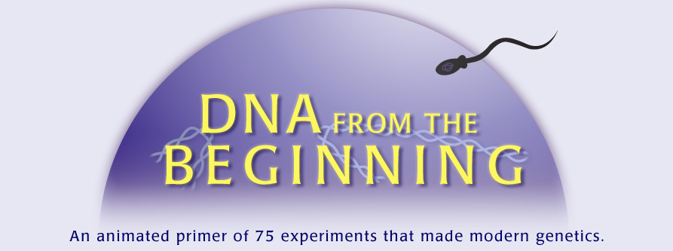

Transition Work - Tracker

There are 6 tasks available in this transition booklet. To complete each one well should take you about 1 and a half to two hours. For your transition work you are expected to complete 8-10 hours of work in total. Therefore you need to complete 4-5 of the tasks above as a minimum. You can of course complete all six if you like!

We look forward to seeing what you produce in September!

Mrs Beatty and Mrs Woodburn

Task | Completed?
Task 1 - DNA and the Genetic Code

Task 2 - Exchange and Transport

Task 3 - Cells

Task 4 - Biological Molecules

Task 5 - Control Systems

Task 6 - Scientific and Investigative Skills

This resource is created using Pixl

